**Automated Testing for Continuous Integration**

**Version 1.0**

**Version History**

|  |  |  |  |
| --- | --- | --- | --- |
| **Version** | **Date** | **Handled by** | **Comments** |
| V1.0 | 05-June-2019 | ZL Chen | Add the software structure. |
| V1.1 | 09-June-2019 | Yuming Lin | Add the project config to Github. |
| V1.1.1 | 11-June-2019 | Yuming Lin | Add the test jobs to Jenkins. |
| V1.2 | 11-June-2019 | ZL Chen | Add the jobs script launch by Jenkins. |
| V1.2.1 | 12-June-2019 | ZL Chen | Add the test report display. |

**System Structure:**

Structure:

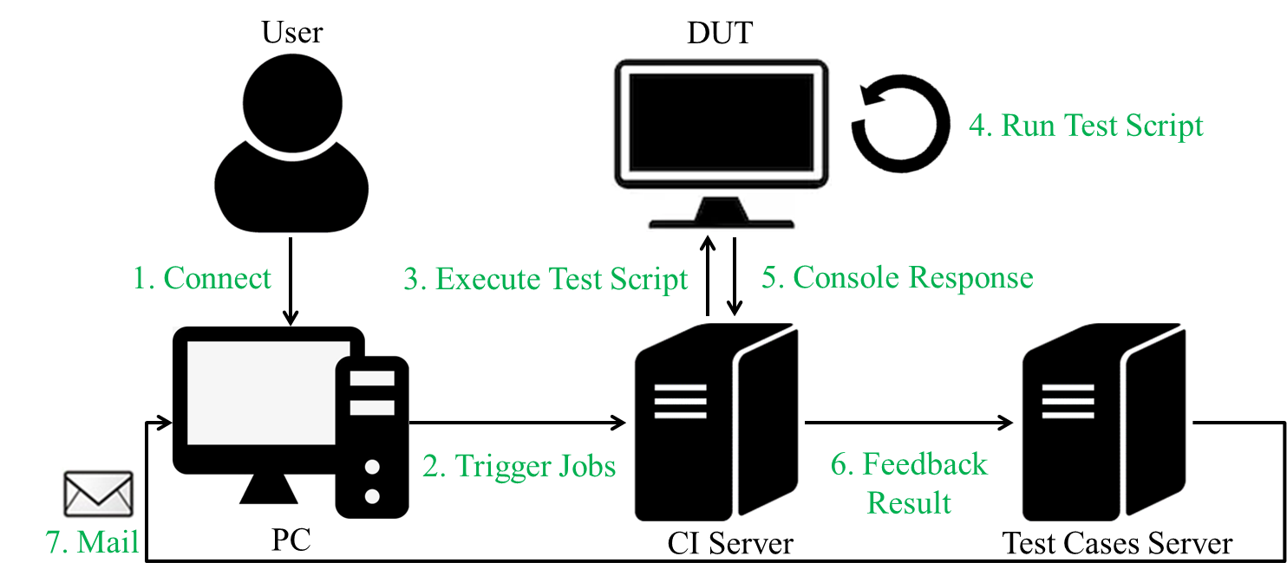

Ongoing:

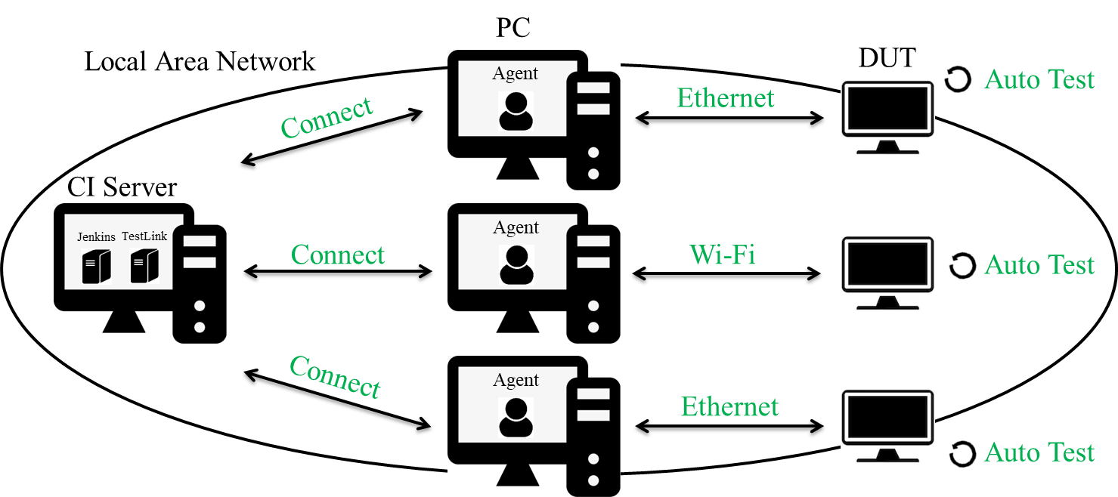

**Precondition Setting:**

Please make sure the DUT is connected to the internet.

**Please follow the implement as below.**

**Step 1:**

Add the project config to Github.

* Please git clone https://github.com/advantech-zl-yuming/ini.git
* Please create the three test branch for xxxxxx branch
  + git checkout -b usc130_a8 origin/usc130_a8
  + git checkout xxxxxx
  + git checkout -b usc130_a8_stress origin/usc130_a8_stress
  + git checkout xxxxxx_stress
  + git checkout -b usc130_a8_half_auto origin/usc130_a8_half_auto
  + git checkout xxxxxx_half_auto

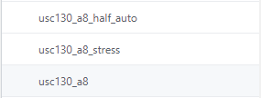

* Please check project components and set components’ parameters on 3 test branches (xxxxxx, xxxxxx_stress, xxxxxx_half_auto)
* Please enable/disable the test module on device_check.ini, and set the components’ parameters on parameter_setting.ini

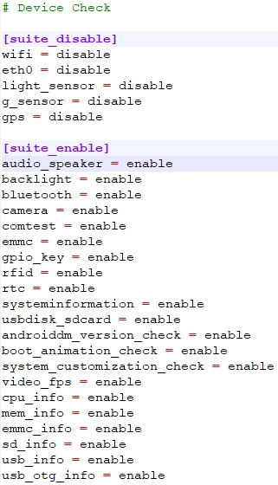 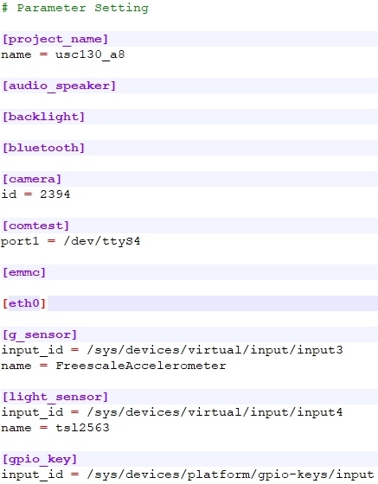

* Please push the three branch to github for test.
* git push origin xxxxxx: xxxxxx
* git push origin xxxxxx_stress: xxxxxx_stress
* git push origin xxxxxx_half_auto: xxxxxx_half_auto

**Step 2:**

Add the test jobs to Jenkins.

* Login the Jenkins system :
  + <http://172.22.20.208:8080/>

(Username and password is default the same.)

* Create new project view
  + Add new xxxxxx project jobs to xxxxxx view 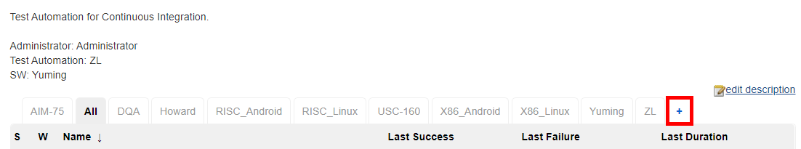

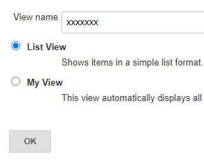

* Add 5 test jobs to new project to run test
  + Add auto test jobs to xxxxxx view

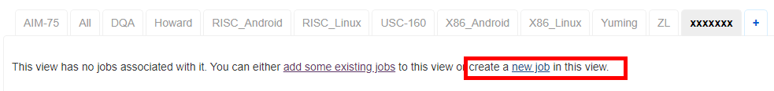

1. Add the auto test config job (Copy from Test_Tools_USC160_Clone_ini_Android)
2. Enter an item name. ex: Test_Tools_ xxxxxx_Clone_ini_Android
3. Set the agent base on the connection.
4. Enter the project config branch name (ex: */xxxxxx)

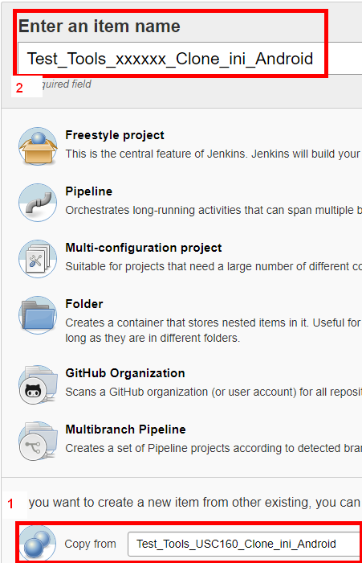 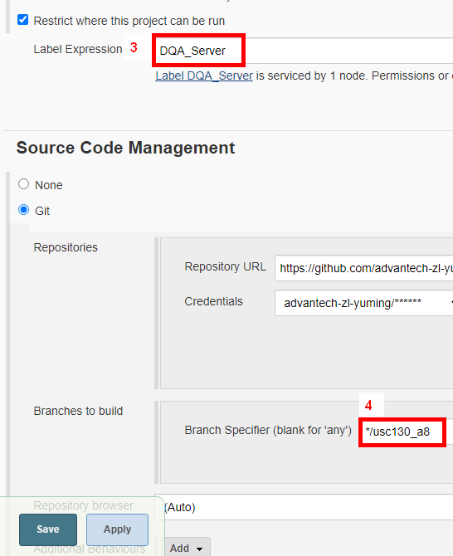

* Add 5 test jobs to new project to run test
  + Add half-auto test jobs to xxxxxx view

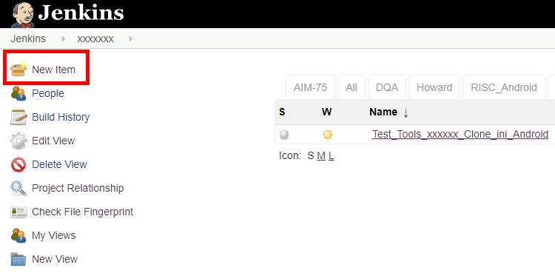

1. Add the half_auto test config job (Copy from Test_Tools_USC160_Clone_ini_half_auto_Android)
2. Enter an item name. ex: Test_Tools_xxxxxx_Clone_ini_half_auto_Android
3. Set the agent base on the connection.
4. Enter the project config branch name (ex: */xxxxxx)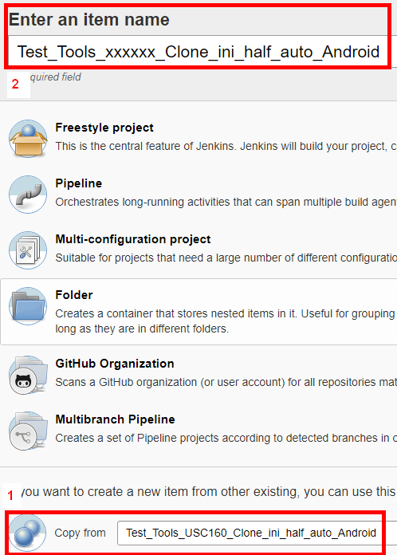
   * Add the stress test jobs to xxxxxx view

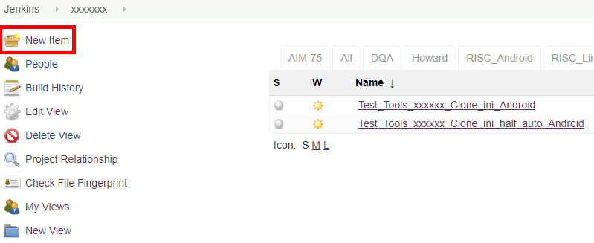

1. Add the stress test config job (Copy from Test_Tools_USC160_Clone_ini_stress_Android)
2. Enter an item name. ex: Test_Tools_xxxxxx_Clone_ini_stress_Android
3. Set the agent base on the connection.
4. Enter the project config branch name (ex: */xxxxxx)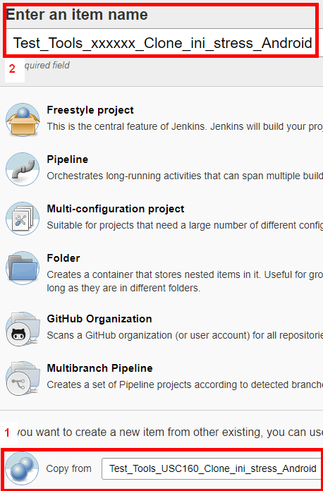
   * Add the download auto tools job and download test APK job to xxxxxx view

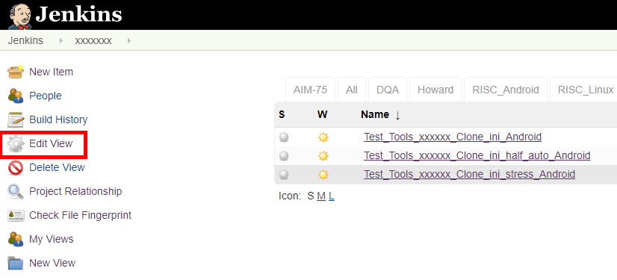Choose the “Test_Tools_USC160_Clone_Automation_Android” and “Test_Tools_USC160_Clone_APK_Android” jobs to the project view to finish 5 test jobs.

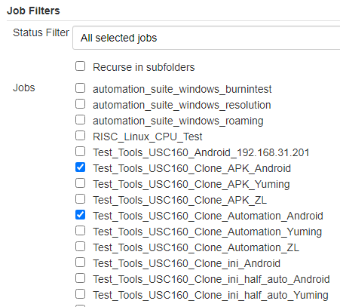

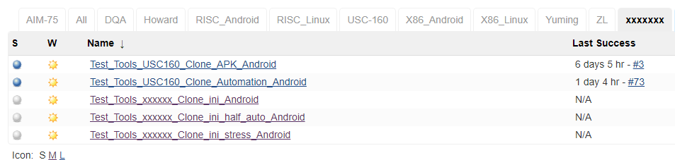

**Step 3:**

Run the jobs script by Jenkins.

The first one:

* Please clone the automation folder. (Click the Test_Tools_USC160_Clone_Automation_Android), it will trigger the “Test_Tools_xxxxx_Clone_ini_Android” jobs.

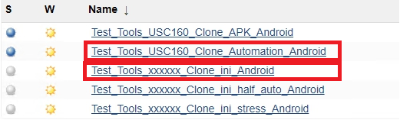

The second:

* If you want to use the APK of the test cases, please click the “Test_Tools_USC160_Clone_APK_Android”, it will trigger the “Test_Tools_xxxxx_ini_half_auto_Android” jobs.

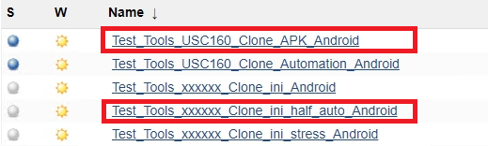

* Then, if you want to run the semiautomatic, please click the “Test_Tools_xxxxx_ini_stress_Android” jobs.

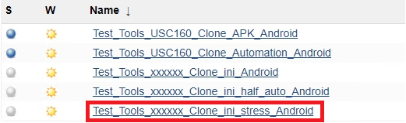

The third,

* Join the main project job. (Ex: Test_Tools_xxxxx)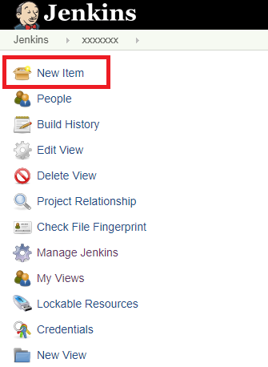

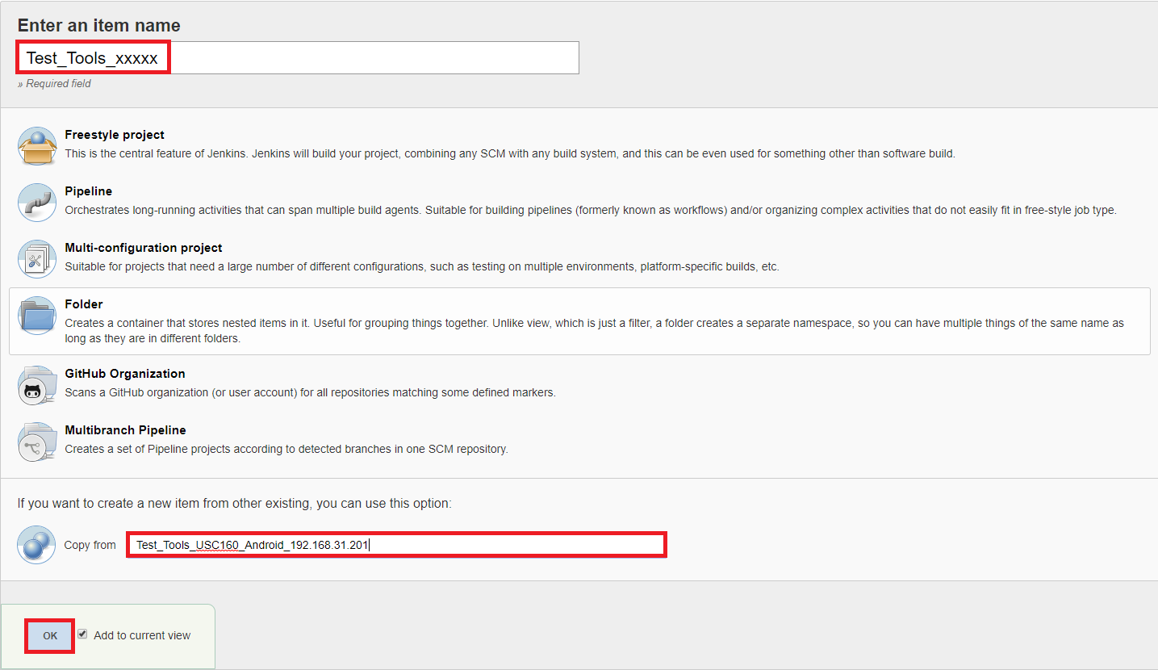

* Modify the configuration setting:
  + Agent



* + IP address:port (Device IP Address)

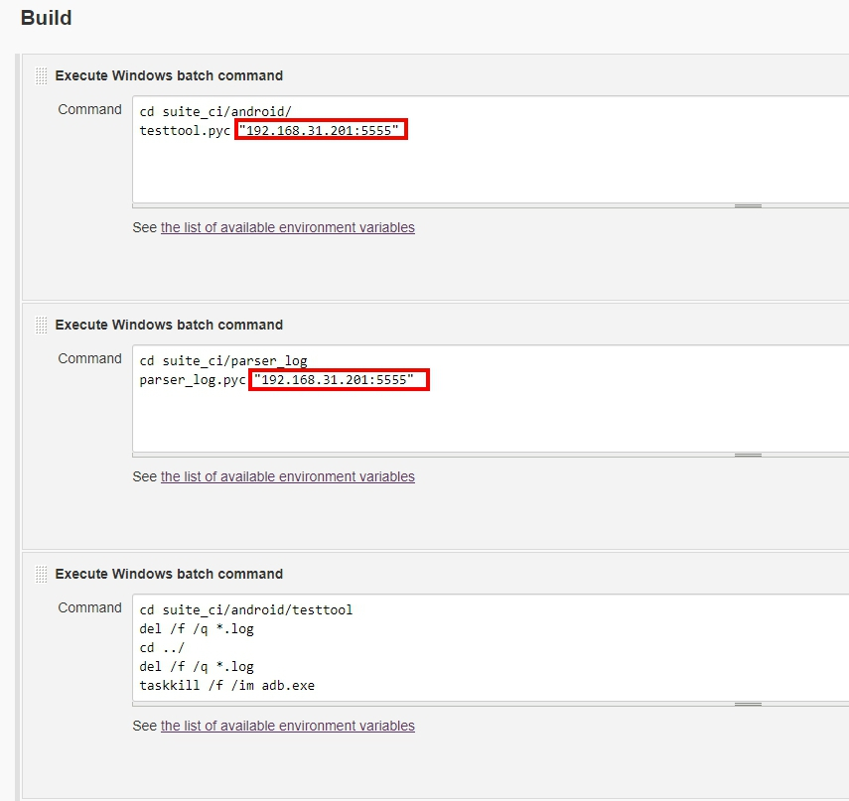

* Finally, starting the auto test script.
  + Please click the “Test_Tools_xxxxx”.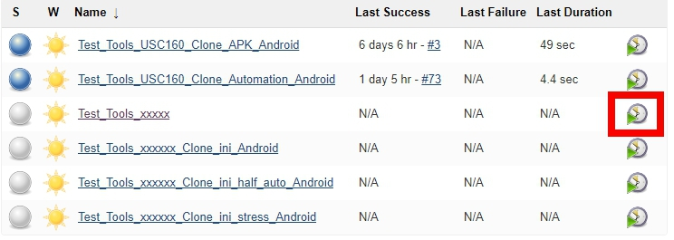

**Step 4:**

* Basically, the location is under the C:\code\automation\parser_log\backup\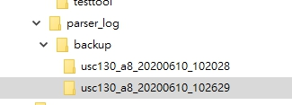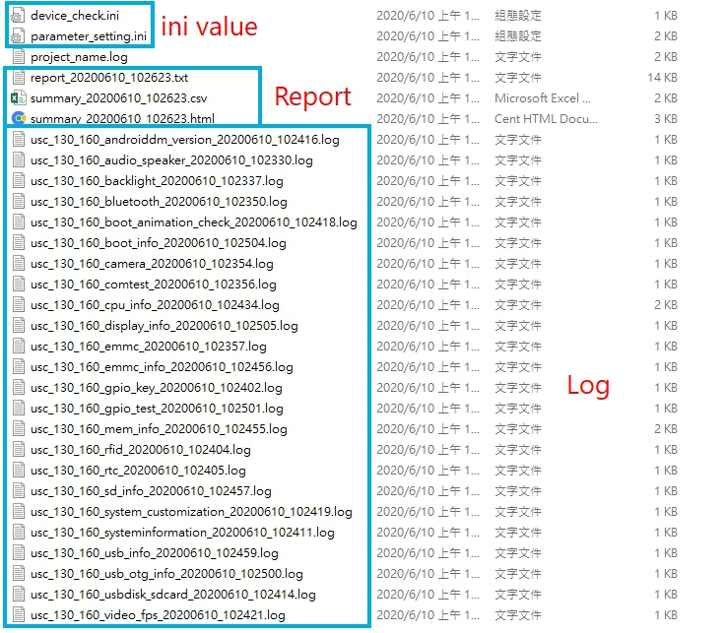
* report_20200610_102623.txt

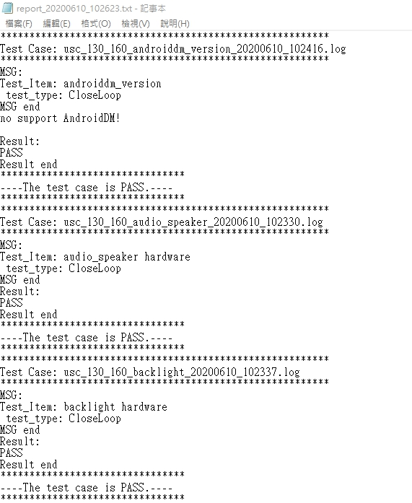

* summary_20200610_102623.html

